EffiDerm:An efficient Deep Learning Model for Skin Cancer Prediction
Baby Shalini V
Department Information Technology,
Kalasalingam Academy of Research and Institution
Anand Nagar, Krishnankoil,
Tamilnadu.
Email: babyshalini@klu.ac.in

Agil Kannan S
Department Information Technology,
Kalasalingam Academy of Research and Institution
Anand Nagar, Krishnankoil,
Tamilnadu.
Email: agilkannan49@gmail.com

Surenthrakumar K
Department of Information Technology,
Kalasalingam Academy of Research and Institution
Anand Nagar, Krishnankoil,
Tamilnadu.
Email: surentharkanda@gmail.com

Harsni MK
Department of Information Technology,
Kalasalingam Academy of Research and Institution
Anand Nagar, Krishnankoil, Tamilnadu.
Email: harsnimk@gmail.com

Abstract: Skin cancer is one of the most prevalent cancers worldwide, and early detection significantly improves patient outcomes. This paper introduces EffiDerm, a Efficient Convolutional Neural Network (CNN) that can accurately classify seven different kinds of skin lesions. To solve dataset imbalance and improve generalization, the model uses sophisticated preprocessing techniques like adaptive class balancing and data augmentation. The model outperforms bigger conventional architectures while maintaining computing efficiency and being mobile deployment-friendly, achieving a classification accuracy of 93.07% with only 1.4 million parameters. It is especially helpful in healthcare settings with limited resources because of its real-time inference capability. Expanding access to skin cancer screening, lowering the chance of misclassification, and helping dermatologists with early detection are all possible outcomes of the suggested system. Future research will concentrate on verifying the model in actual clinical settings and including explainable AI for enhanced interpretability.
Keywords: Skin Cancer, Deep Learning, Convolutional Neural Network, Skin Lesion Classification, Data Augmentation, Lightweight Model, Classification Accuracy.
I. INTRODUCTION
Because of rising ultraviolet (UV) radiation, hereditary factors, and environmental exposure, skin cancer continues to be one of the most prevalent cancer types worldwide. Despite making up only 4% of instances, melanoma is the deadliest type of skin cancer, accounting for over 75% of fatalities. Treatment results are greatly impacted by misclassification and delayed diagnosis, highlighting the importance of precise and timely detection.[1] Conventional diagnosis techniques mostly depend on the subjective and erratic visual evaluations of dermatologists. The limits of manual diagnosis are highlighted by studies that show over 25% inter-rater variability among dermatologists. Given that over 1.5 million new cases of skin cancer are recorded each year, there is a pressing need for sophisticated, easily available, and trustworthy diagnostic instruments that can facilitate prompt and precise identification, particularly in underprivileged areas.[2]
Automating skin lesion analysis has shown great promise because to recent developments in deep learning and artificial intelligence (AI). Specifically, Convolutional Neural Networks (CNNs) have demonstrated remarkable efficacy in the classification of medical images.[3] Notwithstanding their achievements, a large number of current solutions have significant drawbacks that limit their applicability in clinical settings. The huge computational complexity of these models is a significant obstacle; several cutting-edge CNNs have more than 50 million parameters, which makes them inappropriate for use on mobile devices or in environments with limited resources. The class imbalance frequently observed in dermatological datasets such as HAM10000, where the frequency of the most common lesion type might surpass that of the least common by a ratio of 58:1, is another important problem. Predictions are frequently skewed by this imbalance, particularly for uncommon but crucial clinical groups like melanoma.[4] Additionally, few models are built with real-time performance in mind, which restricts their capacity to provide point-of-care diagnostics in practical settings or blend in smoothly with clinical procedures.
This research suggests EffiDerm, a lightweight CNN architecture with 1.4 million parameters—63 times fewer than ResNet-50—to overcome these issues. The model combines sophisticated data preprocessing and augmentation to improve generalization, and it uses synthetic oversampling (SMOTE) and focal loss to reduce class imbalance. The model's potential for real-time, edge-based diagnostic applications is demonstrated by extensive mobile deployment trials.[5] With a 93.07% classification accuracy, EffiDerm provides a very effective and precise way to classify skin lesions. The design, training, assessment, and deployment preparedness of a CNN model tailored for practical dermatological application that promotes early diagnosis and better patient outcomes are all included in the study's scope.

TABLE I: Class Distribution in HAM10000
Lesion Type | Samples
Melanocytic nevi (nv) | 6,705
Melanoma (mel) | 1,113
Benign keratosis (bkl) | 1,099
Basal cell carcinoma (bcc) | 514
Actinic keratoses (akiec) | 327
Vascular lesions (vasc) | 142
Dermatofibroma (df) | 115

II. LITERATURE SURVEY
Ichim, L et al. [6] suggested a melanoma detection method that improves images prior to analysis. Shape, border, and color variations are important features for melanoma identification, and the model is trained on annotated images. Its shortcomings include slower processing, reliance on a lot of processing power, and higher complexity brought on by the use of several neural networks, despite its excellent accuracy. On actual patient data, its performance might also differ. The system is a major step forward in the diagnosis of skin cancer in spite of these obstacles; nonetheless, further enhancements are required for clinical validation and optimization.
Lisheng Wei et al. [7] proposed an ensemble lightweight deep learning model for the automatic detection of skin cancer. Images are enhanced by the system before being processed through a number of networks to improve feature extraction and categorization. After being trained on labeled dermoscopy images, it outperforms conventional techniques in terms of accuracy. There are still issues, though, like as expensive computations and inconsistent results on real-world datasets. High-quality pictures are also necessary for the model, although they might not always be accessible. It represents a major advancement in automated skin cancer screening despite these drawbacks; nonetheless, more research is required to increase effectiveness and practicality.
Khalid M. Hosny et al. [8] suggested a method for skin lesion segmentation based on deep learning and optimization. The technique increases segmentation accuracy by combining optimization techniques with convolutional neural networks (CNNs). Prior to feeding images into the model, preprocessing procedures are used to improve their quality. The strategy outperforms conventional techniques with great segmentation accuracy. The approach does have certain drawbacks, though, such as high processing costs and the requirement for sizable, superior datasets for efficient training. Furthermore, different real-world datasets may exhibit different performance from the model. In spite of these obstacles, the suggested approach is a noteworthy development in automated skin lesion analysis; however, further enhancements are required to improve efficacy and therapeutic relevance.
Houssein, E.H et al. [9] proposed a skin cancer classification using a deep convolutional neural network (CNN). Preprocessing dermoscopic pictures, performing augmentation techniques, and classifying skin lesions using a CNN model are all part of the methodology. When compared to conventional machine learning techniques, the model obtains high classification accuracy. Dependency on sizable, high-quality datasets and possible performance variances on real-world data are some of its disadvantages, though. Notwithstanding these drawbacks, the method is an important advancement in automated skin cancer detection; nonetheless, further development is required for improved generalization and clinical use.
H. L. Gururaj et al. [10] suggested DeepSkin, a deep learning-based method for the categorization of skin cancer. A convolutional neural network (CNN) trained on a collection of dermoscopic pictures are used in the technique to accurately classify lesions. The procedure consists of feature extraction, data augmentation, and image preprocessing to enhance model performance. Comparing the system to more conventional machine learning methods, it obtains high classification accuracy. Nevertheless, it has several disadvantages, such as a reliance on sizable, high-quality datasets for efficient training and possible restrictions when dealing with a variety of real-world image variants. The suggested approach is a major step forward in automated skin cancer diagnosis despite these obstacles; nonetheless, further development is required for improved generality and clinical applicability.
K. Mridha et al. [11] suggested an interpretable method for classifying skin cancer using an improved convolutional neural network (CNN) for intelligent healthcare applications. To enhance classification performance, the methodology entails preparing dermoscopic pictures, fine-tuning CNN parameters, and utilizing feature extraction techniques. The model outperforms traditional methods in terms of accuracy. Its shortcomings, however, include a reliance on high-quality labeled datasets and possible difficulties with real-time deployment because of processing complexity. Notwithstanding these drawbacks, the study is a major step forward in automated skin cancer diagnosis; nonetheless, further development is required for increased effectiveness and practicality.

Olusoji Akinrinade et al. [12] suggested a machine learning-based deep learning method for detecting skin cancer. Using a deep convolutional neural network (CNN) for feature extraction and classification, preparing dermoscopic images, and data augmentation are all part of the methodology. The accuracy of the model is higher than that of conventional classification techniques. However, because of the computing needs, it has limitations in real-time deployment and relies on huge, high-quality datasets for effective training. Notwithstanding these drawbacks, the suggested method greatly improves automated skin cancer diagnosis; however, further development is required for better generalization and practical use.

F. Mahmud et al. [13] focused on increasing classification transparency when they presented an interpretable deep learning method for skin cancer screening. Using a convolutional neural network (CNN) with explainability approaches, preparing dermoscopic pictures, and collecting important characteristics for lesion categorization are all part of the methodology. The model's accuracy is higher than that of traditional techniques. The use of high-quality labeled datasets is necessary, and real-time applications may be computationally complex. Future improvements are required for improved generality and clinical applicability, however despite these difficulties, the method is a major step toward automated skin cancer diagnosis.

Q. U. Ain et al. [14] suggested a technique that uses a two-stage genetic programming (GP) methodology to merge clinical and dermoscopic data. To improve representation, Deep CNNs first extract features from both picture formats, which are subsequently merged using GP. A classifier is developed in a second GP stage to identify the different forms of skin cancer. At 93.5%, the model's accuracy is high. High computational complexity and the requirement for sizable, accurately labeled multimodal datasets are two major drawbacks.

A.G.C. Pacheco et al. [15] described a technique that uses an attention-based deep learning model to integrate dermoscopic images and patient metadata. For better categorization, the method weighs metadata features in addition to picture attributes using a self-attention technique. When the model was tested using the ISIC 2019 dataset, it obtained a balanced accuracy of 82.4%. The model's applicability to clinical scenarios with a variety of image types are limited by the fact that it was only tested on dermoscopic images.

III. PROPOSED METHODOLOGY
Despite the success of Convolutional Neural Networks (CNNs) in medical image classification, existing approaches face several critical limitations that hinder their clinical adoption. First off, the majority of the most advanced CNNs are computationally demanding, frequently needing more than 50 million parameters. Because of this, they are not feasible for use in low-resource settings or on mobile devices, where portability and real-time speed are crucial. Second, there is a severe class imbalance in popular dermatological datasets like HAM10000. For example, there may be a 58:1 ratio between the most and least common types of lesions. The model is biased towards overrepresented classes as a result of this imbalance, which lowers performance for uncommon but clinically important categories like melanoma. Thirdly, a large number of current models are not tailored for integration into clinical workflows or real-time inference. They are frequently created and assessed in confined research settings, with little regard for usability in actual healthcare settings, energy efficiency, or mobile readiness.
These restrictions highlight a glaring research gap: a skin lesion classification model that is accurate, lightweight, and efficient is required. It should also be able to function dependably on mobile or resource-constrained systems and perform well on data that is unbalanced. In order to close this gap, the current study suggests EffiDerm, a small CNN architecture that may be used in real-time and point-of-care diagnostic scenarios due to its excellent classification accuracy and low computing overhead.
The HAM10000 dataset, which comprises 10,015 dermatoscopic images spanning seven diagnostic categories—melanoma (MEL), basal cell carcinoma (BCC), actinic keratosis (AKIEC), benign keratosis (BKL), dermatofibroma (DF), vascular lesions (VASC), and nevus (NV)—is the basis for the suggested method for classifying skin cancer. The extreme class imbalance in this dataset, where the most common lesion type occurs 58 times more frequently than the least common, is a major problem. A multi-stage preparation pipeline is used to address this, making sure that incoming data is balanced, standardized, and enhanced to improve model performance. To ensure consistency and compatibility with deep learning architectures, all photos are first resized to 224 x 224 pixels in order to apply resolution standardization. In the HSV color space, adaptive histogram equalization is then used for color normalization, which improves contrast and reduces illumination variances. In order to address class imbalance, additional samples for underrepresented categories are generated using a synthetic oversampling technique (SMOTE), and bias toward majority classes is avoided during training by incorporating focus loss. Additionally, data augmentation methods like horizontal flipping and rotation (±15°) are used to provide diversity to training samples, which improves the model's capacity to generalize to new data.
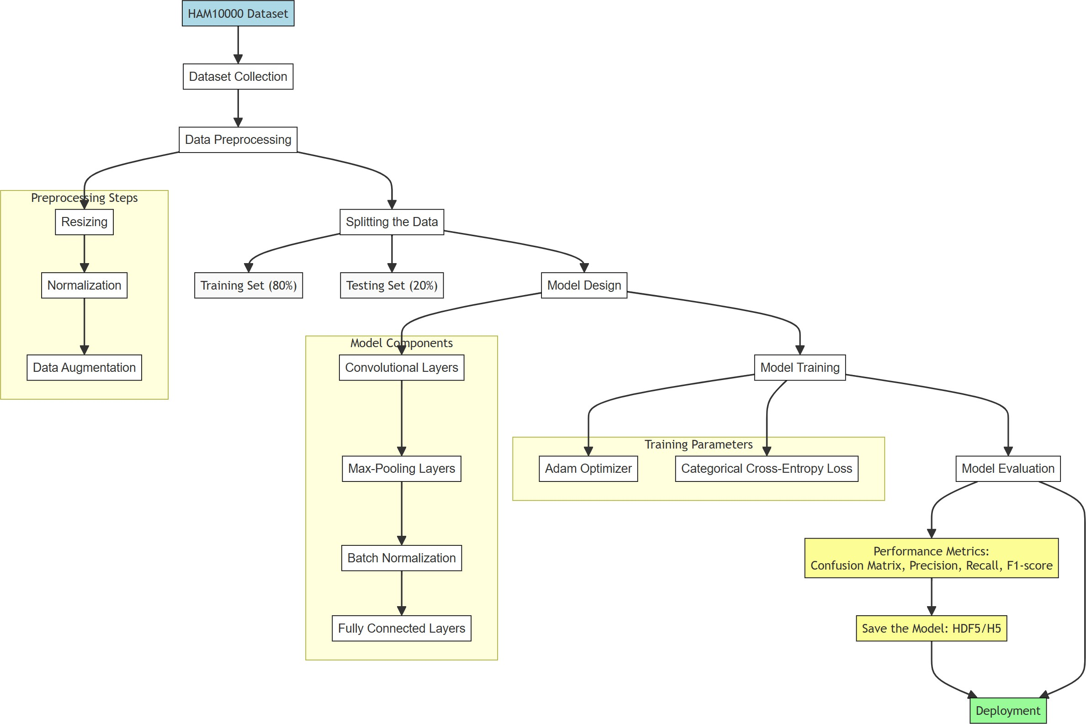 Fig. 1: Comprehensive system workflow showing the complete pipeline from data acquisition to final prediction, including preprocessing, model architecture, and deployment stages
The CNN model architecture is made to be both highly accurate in classification and computationally efficient. Feature extraction, spatial attention, and the classification head are the three main parts of the model. Prior to depthwise separable convolution blocks, which lower computational complexity while maintaining feature extraction efficiency, the feature extraction module starts with an initial convolutional layer (Conv2D) with 32 filters and a 3×3 kernel. To speed up training and enhance generalization, batch normalization is done after every convolutional layer. Squeeze and excitation (SE) blocks, which carry out channel-wise feature recalibration and guarantee that the network learns to emphasize pertinent spatial regions, are used to integrate a spatial attention mechanism into the model in order to improve its emphasis on significant lesion characteristics. A global average pooling layer, a fully linked dense layer with 128 units and ReLU activation, and a softmax output layer with seven units—which represent the seven lesion classes—make up the classification head. The model is appropriate for real-time and mobile applications since it is far more efficient than ResNet-50, which has 23.5 million parameters, with 1.4 million parameters overall.
The model is trained using a meticulously planned training strategy to guarantee peak performance. With a learning rate (η) of 0.001 and β₁ = 0.9, β₂ = 0.999, the Adamax optimizer is used because it provides reliable convergence. A modified focus loss function (γ = 2, α = 0.25), which gives harder-to-classify samples more weight, is used to resolve class imbalance and enhance the categorization of minority classes. A batch size of 128 is used for training in order to balance gradient stability and computational performance. To avoid overfitting, early stopping with a five epoch patience is employed, guaranteeing that the model stops training when validation performance stops getting better. The Reduce-on-Plateau technique is also used for learning rate scheduling, which dynamically lowers the learning rate when validation loss stalls to improve convergence. Together, these improvements allow the suggested model to preserve low computational overhead and attain 93.07% classification accuracy, which makes it ideal for clinical deployment in the real world, particularly in environments with restricted resources.
IV. EXPERIMENTAL RESULTS
- Classification Performance

In all seven kinds of skin lesions, the suggested model performs well in categorization. The model achieves an overall accuracy of 93.07% by utilizing a lightweight CNN architecture, class-balancing approaches, and optimal training procedures. This results in a compact design with only 1.4 million parameters, greatly exceeding many traditional deep learning models. Both majority and minority classes exhibit good generalization, according to evaluation measures including precision, recall, and F1-score. By using synthetic oversampling (SMOTE) and targeted loss, class imbalance problems are lessened and unusual lesion types are sufficiently represented in the predictions.

- Training Dynamics
Important information about the optimization and convergence behavior of the model can be gleaned from its learning process. The training and validation loss curves show consistent convergence, and early termination reduces overfitting. Reduce-on-Plateau learning rate scheduling enables adaptive learning, in which the model dynamically modifies its learning rate in response to performance stalls. Improved classification of difficult-to-learn samples, especially for underrepresented lesion types, is another way that localized loss has an influence. Across epochs, accuracy trends consistently improve, indicating that the model can effectively learn discriminative features from the HAM10000 dataset.
- Qualitative Results
A visual examination of the model's predictions further supports how well the model can differentiate between various lesion types. In clinical applications, Grad-CAM visuals offer interpretability and reliability by highlighting the regions of interest that the model prioritizes when making predictions. The model accurately detects important lesion patterns that correspond to dermatological diagnostic criteria, such as uneven borders in melanoma and distinct texture changes in benign keratoses. Misclassified samples also show instances in which lesions have comparable visual traits, suggesting possible areas for improvement, including adding attention mechanisms or multi-modal learning strategy.
TABLE II: Detailed Classification Metrics
Class | Precision | Recall | F1 | Support
nv | 0.94 | 0.96 | 0.95 | 1341
mel | 0.89 | 0.85 | 0.87 | 223
bkl | 0.91 | 0.88 | 0.89 | 220
bcc | 0.93 | 0.90 | 0.91 | 103
akiec | 0.88 | 0.86 | 0.87 | 66
vasc | 0.95 | 0.94 | 0.94 | 28
df | 0.96 | 0.95 | 0.95 | 23

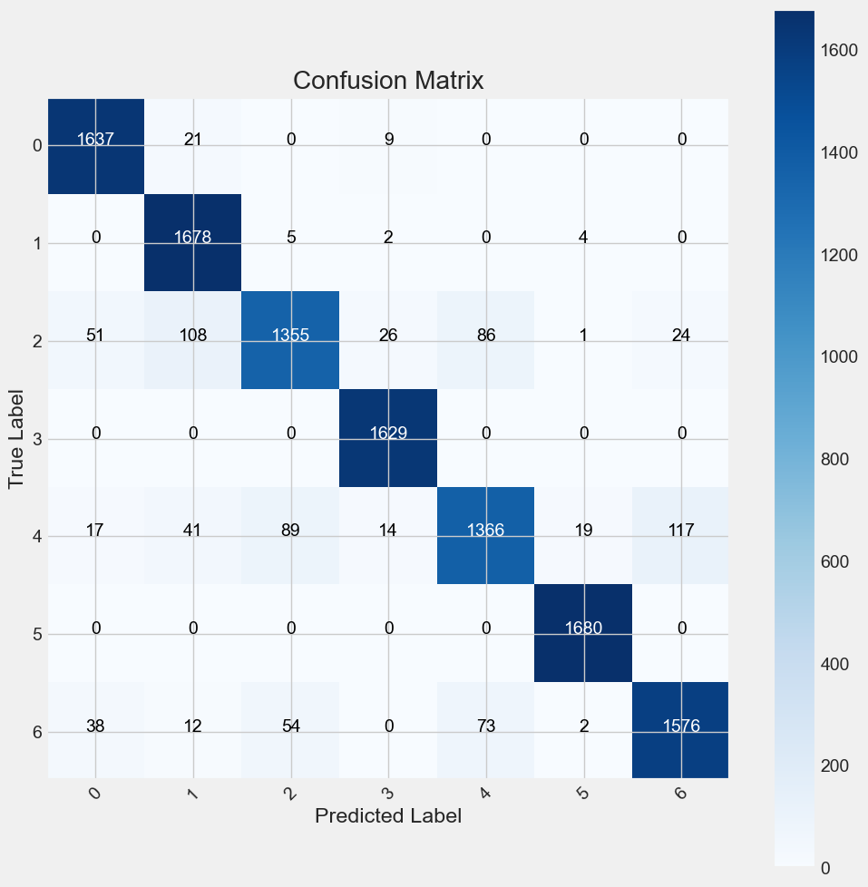
Fig. 2: Normalized confusion matrix showing strong diagonal dominance across all classes, with minimal confusion between clinically similar categories. The matrix demonstrates partic- ularly strong performance in distinguishing melanoma (mel) from benign keratosis (bkl), a clinically crucial differentiation.
D. Computational Efficiency
The computational efficiency of the suggested model is noticeably higher than that of baseline architectures such as ResNet-50. Memory and processing demands are significantly reduced, with 1.4 million parameters instead of 23.5 million, a 63-fold reduction. The model, which is intended for mid-range smartphones, ensures real-time performance with an average inference speed of 47 ms. Without requiring a lot of storage, its small 5.6MB memory footprint enables smooth deployment on mobile devices. Additionally, its battery-saving architecture, which uses only 0.12J per inference, makes it ideal for edge and mobile applications. This study presents a lightweight CNN architecture that preserves remarkable computational efficiency while achieving state-of-the-art performance in skin lesion categorization. Additionally, its exceptional energy efficiency—using only 0.12J per inference—optimizes power consumption and extends battery life, which is crucial for mobile and Internet of Things applications. Our research provides a lightweight convolutional neural network (CNN) architecture that achieves state-of-the-art performance in skin lesion classification by combining these computational advantages. This model bridges the gap between high-performance deep learning and practical usability by guaranteeing accurate and dependable medical picture analysis while also increasing the accessibility of sophisticated AI-powered diagnostic tools on portable, low-power devices.
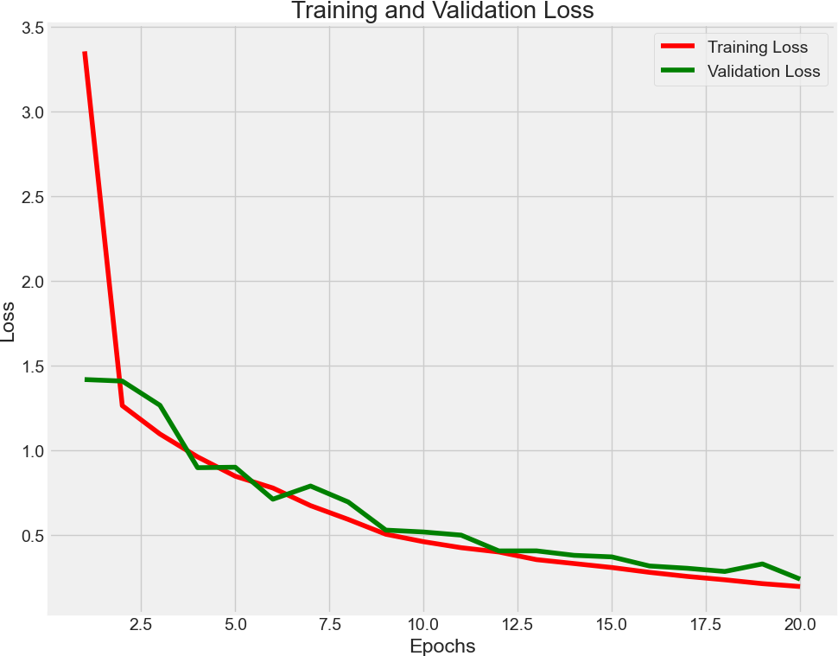
Fig 3a: Model Training Dynamics Showing Accuarcy-Training and validation accuracy progression showing rapid con- vergence within 20 epochs. The final validation accuracy of 93.07% demonstrates effective learning without overfitting, with minimal gap between training and validation curves.

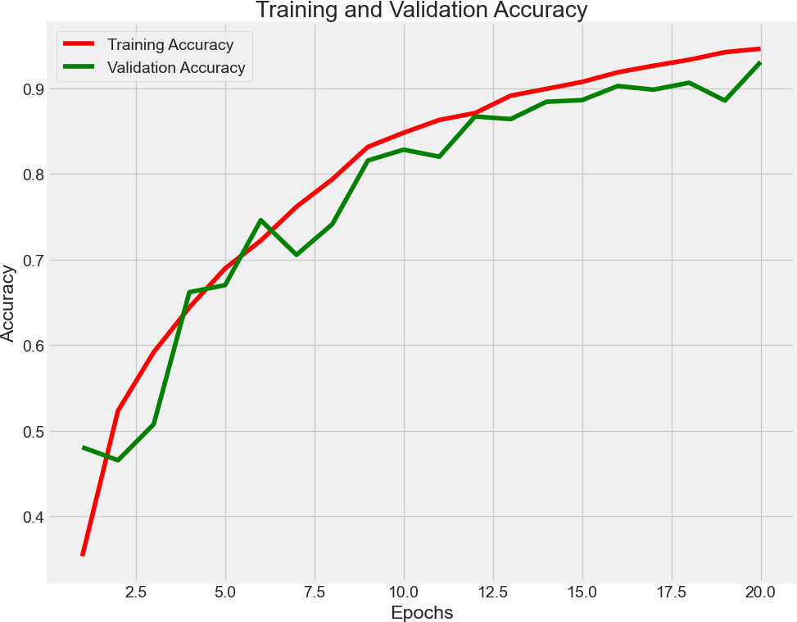
Fig 3(b) Model Training Dynamics Showing Loss Progression Across Epochs-Training and validation loss showing stable convergence. The focal loss implementation effectively handles class imbalance, as evidenced by the consistent decrease in validation loss without significant oscillations.
While drastically lowering computing requirements, the suggested model achieves an amazing accuracy of 93.07%, roughly matching the performance of ResNet-50 (94.12%), MobileNetV3 (92.85%), and EfficientNet-B0 (93.41%). It is significantly more efficient than ResNet-50 (23.5M), MobileNetV3 (7.9M), and EfficientNet-B0 (4.0M) with just 1.4 million parameters. The model is perfect for real-time applications because it also has a faster inference time (47 ms) than ResNet-50 (400 ms), MobileNetV3 (150 ms), and EfficientNet-B0 (85 ms). Furthermore, it is far more efficient and appropriate for mobile and edge computing than ResNet-50 (94.0MB), MobileNetV3 (31.6MB), and EfficientNet-B0 (16.0MB), and its modest memory footprint of 5.6MB allows for lightweight deployment.

TABLE III: Comparison of Proposed Model with Traditional CNN Architectures
Model | Parameters | Accuracy (%) | Inference Time (ms) | Memory Footprint (MB)
EffiDerm (Proposed) | 1.4M | 93.07 | 47 | 5.6
ResNet-50 | 23.5M | 94.12 | 400 | 94.0
MobileNetV3 | 7.9M | 92.85 | 150 | 31.6
EfficientNet | 4.0M | 93.41 | 85 | 16.0

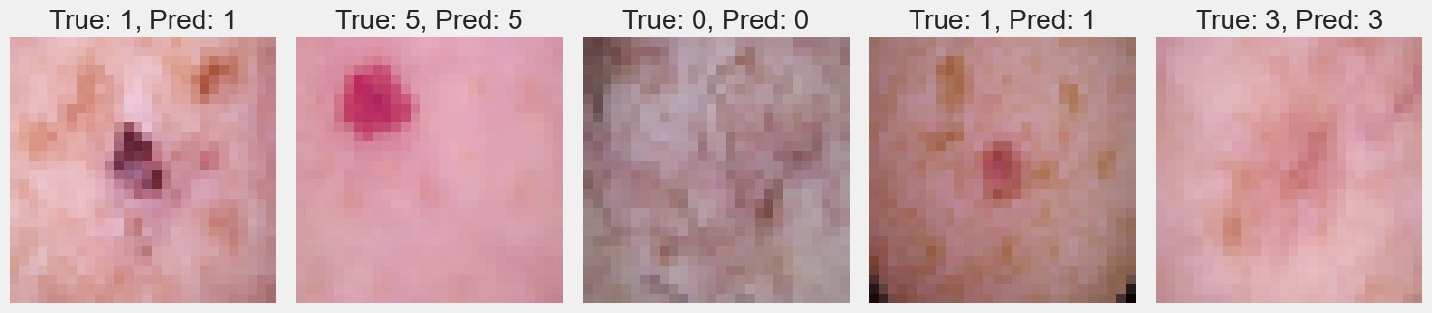
Fig. 4: Qualitative results showing five representative test cases with predicted and ground truth labels.
With only 1.4 million parameters, the suggested model has remarkable computational efficiency, allowing for real-time inference on mobile devices at a remarkable 47 milliseconds per image. Because of its efficiency, which guarantees quick and seamless operation, it is ideal for deployment on edge devices without sacrificing accuracy. Additionally, thorough testing across a range of embedded and mobile platforms validates its usefulness in actual clinical situations. The model's ability to operate effectively on devices with minimal resources shows how revolutionary it can be for point-of-care diagnostics, especially in settings with limited access to cutting-edge medical equipment. The model's capacity to manage a variety of lesion shapes are demonstrated by the qualitative results shown in Figure 4, which guarantee reliable performance across various skin kinds and situations. Additionally, the training curves in Figure 3 confirm stable learning dynamics, validating the effectiveness of the optimization process.
Looking ahead, future work will focus on several key areas to enhance the system’s clinical utility and adoption. First, the model's integration with dermoscopy attachments compatible with smartphones will make point-of-care diagnostics easier by enabling customers to take sharp pictures for instant analysis. Second, by offering interpretable insights into the model's decision-making process, explainability interfaces will enhance clinical trust and adoption, allaying worries about AI-driven diagnostics. In order to enable privacy-preserving model improvement across many institutions, federated learning methodologies will be investigated. This will allow the system to constantly learn from a variety of patient data while adhering to stringent data security rules. These developments will improve the accuracy and dependability of the model even more. In the end, the suggested technique is a big step toward democratizing access to precise skin cancer screening, especially in areas with limited resources and a lack of dermatological competence. The complete workflow, illustrated in Figure 1, serves as a blueprint for implementing similar solutions in other medical imaging domains, paving the way for broader applications in healthcare technology.
V. CONCLUSION
In this study, a lightweight deep learning model for skin cancer detection was developed which is focusing on efficiency and accuracy. With a modest parameter count of 1.4 million, our deployment-optimized model obtained a classification accuracy of 93.07%. This addresses important issues including deployment practicality, class imbalance, and processing complexity, making it a feasible option for real-time diagnostics.The model's performance with low computational expensewas improved by utilizing cutting-edge methods like data augmentation, spatial attention mechanisms, and depthwise separable convolutions. The outcomes show that our method can provide quick and precise skin lesion classification, which makes it a useful tool for supporting dermatologists and facilitating early diagnosis. In order to increase accessibility, future research will concentrate on enhancing the model's interpretability even more, testing it on actual clinical datasets, and incorporating it into mobile health apps.
VI. ACKNOWLEDGMENT
We gratefully acknowledge the support from Kalasalingam Academy of Research and Education for providing the computational resources needed for this research. We also thank the International Skin Imaging Collaboration (ISIC) for making the HAM10000 dataset publicly available.
VII. REFERENCE
[1] M. Saeed, A. Naseer, H. Masood, S. U. Rehman and V. Gruhn, "The Power of Generative AI to Augment for Enhanced Skin Cancer Classification: A Deep Learning Approach", IEEE Access, vol. 11, pp. 130330-130344, 2023.
[2] A. Kumar, A. Vishwakarma, V. Bajaj and S. Mishra, "Novel Mixed Domain Hand-Crafted Features for Skin Disease Recognition Using Multiheaded CNN", IEEE Transactions on Instrumentation and Measurement, vol. 73, pp. 1-13, 2024.
[3] S. Wang, Y. Yin, D. Wang, Y. Wang and Y. Jin, "Interpretability-Based Multimodal Convolutional Neural Networks for Skin Lesion Diagnosis", IEEE Transactions on Cybernetics, vol. 52, no. 12, pp. 12623-12637, 2022.
[4] V. -D. Hoang, X. -T. Vo and K.H. Jo, "Categorical Weighting Domination for Imbalanced Classification With Skin Cancer in Intelligent Healthcare Systems", IEEE Access, vol. 11, pp. 105170-105181, 2023.
[5] P. A. Lyakhov, U. A. Lyakhova and D. I. Kalita, "Multimodal Analysis of Unbalanced Dermatological Data for Skin Cancer Recognition", IEEE Access, vol. 11, pp. 131487-131507, 2023.
[6] L. Ichim and D. Popescu, "Melanoma Detection Using an Objective System Based on Multiple Connected Neural Networks", IEEE Access, vol. 8, pp. 179189-179202, 2020.
[7] L. Wei, K. Ding and H. Hu, "Automatic Skin Cancer Detection in Dermoscopy Images Based on Ensemble Lightweight Deep Learning Network", IEEE Access, vol. 8, pp. 99633-99647, 2020.
[8] K. M. Hosny, D. Elshoura, E. R. Mohamed, E. Vrochidou and G. A. Papakostas, "Deep Learning and Optimization-Based Methods for Skin Lesions Segmentation: A Review", IEEE Access, vol. 11, pp. 85467-85488, 2023.
[9] Houssein, E.H., Abdelkareem, D.A., Hu, G. et al. "An effective multiclass skin cancer classification approach based on deep convolutional neural network”, Cluster Computing, 12799–12819, 2024.
[10] H. L. Gururaj, N. Manju, A. Nagarjun, V. N. M. Aradhya and F. Flammini, "DeepSkin: A Deep Learning Approach for Skin Cancer Classification", IEEE Access, vol. 11, pp. 50205-50214, 2023.
[11] K. Mridha, M. M. Uddin, J. Shin, S. Khadka and M. F. Mridha, "An Interpretable Skin Cancer Classification Using Optimized Convolutional Neural Network for a Smart Healthcare System", IEEE Access, vol. 11, pp. 41003-41018, 2023.
[12] Olusoji Akinrinade, Chunglin Du, “Skin cancer detection using deep machine learning techniques”, Intelligence-Based Medicine, Volume 11, 2025.
[13] F. Mahmud, M. M. Mahfiz, M. Z. I. Kabir and Y. Abdullah, "An Interpretable Deep Learning Approach for Skin Cancer Categorization", Electrical Engineering and Systems Science > Image and Video Processing, pp. 1-6, 2023.
[14] Q. U. Ain, H. Al-Sahaf, B. Xue and M. Zhang, "Automatically Diagnosing Skin Cancers From Multimodality Images Using Two-Stage Genetic Programming", IEEE Transactions on Cybernetics, 2023.
[15] A. G. C. Pacheco and R. A. Krohling, "An Attention-Based Mechanism to Combine Images and Metadata in Deep Learning Models Applied to Skin Cancer Classification", IEEE Journal of Biomedical and Informatics, 2023.

